1. What do you mean by cells in an excel sheet?

A cell is an essential part of MS-Excel. It is an object of Excel worksheets. Whenever you open Excel, the Excel worksheet contains cells to store the information in them. You enter content and your data into these cells. Cells are the building blocks of the Excel worksheet. So, you should know every single point about it.

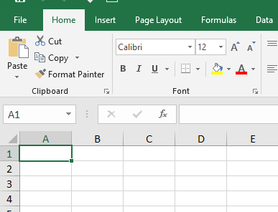

This is a cell in Excel Sheet

2. How can you restrict someone from copying a cell from your worksheet?

go into Menu bar >Review > Protect sheet > Password. By entering password, you can secure your worksheet from getting copied by others.

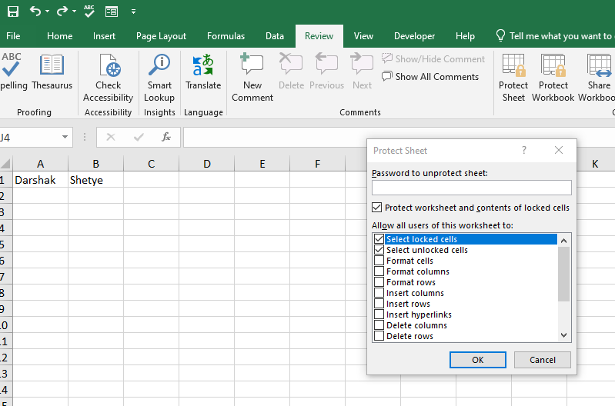

Go in review tab

Select protect sheet

Set a password and click ok

3. How to move or copy the worksheet into another workbook?

a. Right click on tab that you want to copy

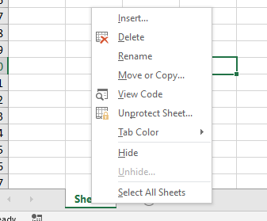

b. Select the workbook in which you want to copy (Excel only display workbook which are open).

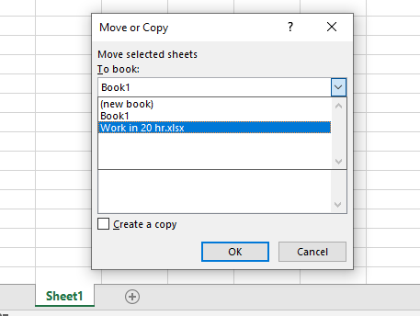

c. Select the position of the sheet in new workbook and click ok.

4. Which key is used as a shortcut for opening a new window document?

Ctrl + 1 in excel is use to open new document.

5. What are the things that we can notice after opening the Excel interface?

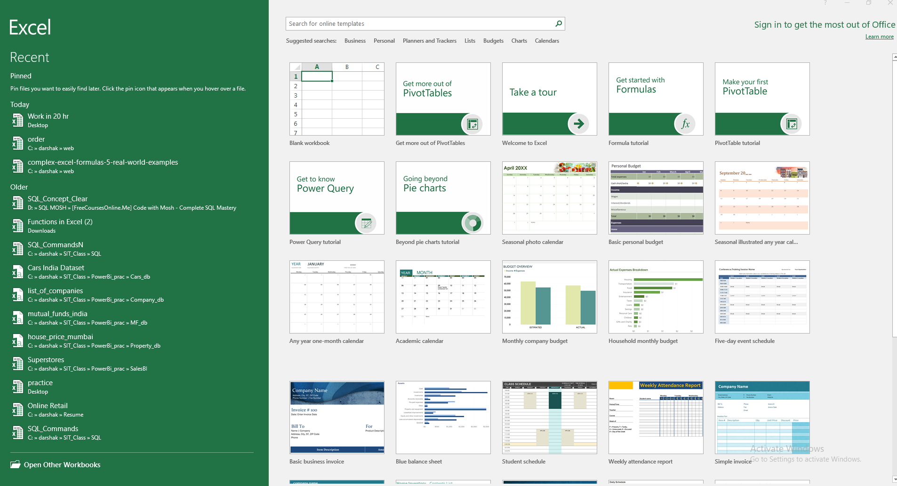

Recent File and Older file

Templates from Ms Excel to use

6. When to use a relative cell reference in excel?

Relative reference should be use when we want to change the relative position (reference) based on column or rows.

For example :

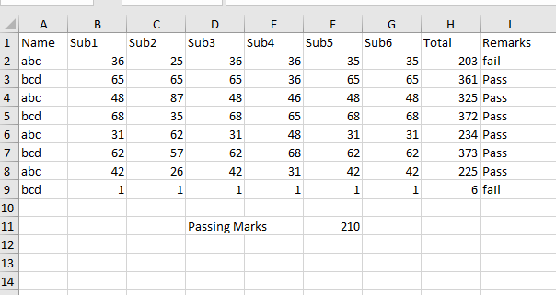

H2: =SUM(B2:G2)

gives the sum of “b2:g2” – here the reference is relative by default and change if we drag the function till “h9”.

I2 : =IF($F$11<H2,"Pass","fail")

In it f11 is an absolute reference used inside formula which doesn’t change if we drag the formula till “h9”.